# Description of commodity or product

In this assignment, we will analyze the change in weekly sales with the change in independent variables including temperature, fuel price and the number of holidays.

# Difference between a movement along the demand/sales curve and a shift in demand curve

Demand refers to the quantity of a commodity the customer is willing and capable to purchase, at any given time and at each possible price.

The demand curve is a graphical representation of the relationship between the price of a good or service and the quantity demanded for a given period of time. In a typical representation, the price appears on the left vertical axis while the quantity demanded is on the horizontal axis. A demand curve doesn't look the same for every product or service. When the price rises, demand generally falls for almost any good, but the drop is much greater for some goods than for others. This is a reflection of the price elasticity of demand, a measurement of the change in consumption of a product in relation to a change in its price. The elasticity of demand for products varies between and within product categories, depending on the product’s substitutability.

A shift in demand means at the same price, consumers wish to buy more. A movement along the demand curve occurs following a change in price.

### **Movement along the demand curve**

A change in price causes a movement along the demand curve. It can either be contraction (less demand) or expansion/extension. (more demand)

[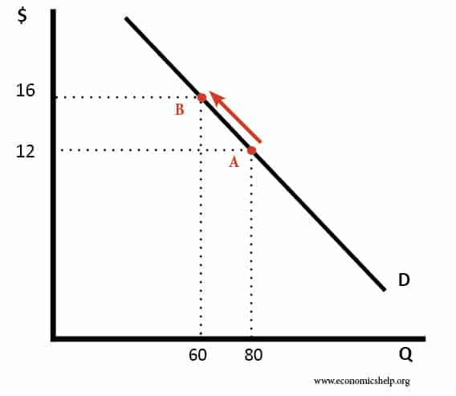](https://www.economicshelp.org/wp-content/uploads/2008/06/movement-along-demand-curve.jpg)

**Contraction in demand**. An increase in price from $12 to $16 causes a movement along the demand curve, and quantity demand falls from 80 to 60. We say this is a contraction in demand

**Expansion in demand**. A fall in price from $16 to $12 leads to an expansion (increase) in demand. As price falls, there is a movement along the demand curve and more is bought.

[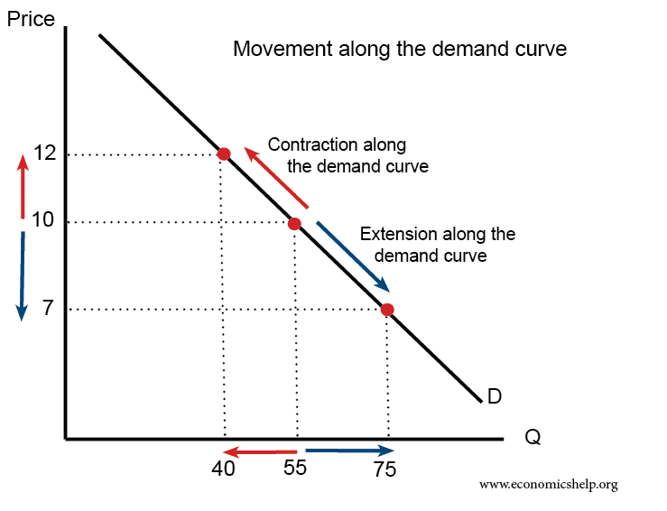](https://www.economicshelp.org/wp-content/uploads/2019/06/movement-along-demand.png)

A change in price doesn’t shift the demand curve – we merely move from one point of the demand curve to another.

### Shift in the Demand Curve

[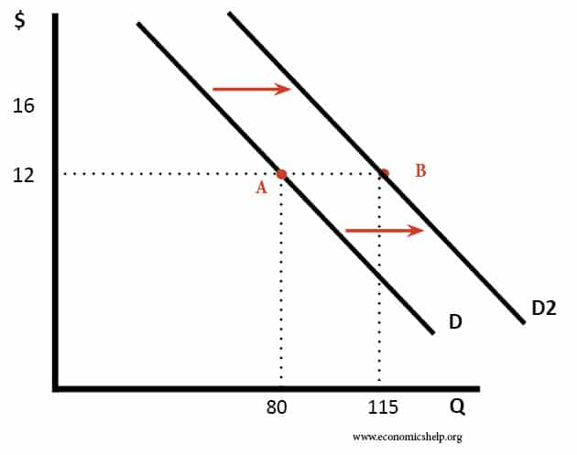](https://www.economicshelp.org/wp-content/uploads/2008/06/shift-in-demand.jpg)

A shift in the demand curve occurs when the whole demand curve moves to the right or left. For example, an increase in income would mean people can afford to buy more widgets even at the same price.

The demand curve could shift to the right for the following reasons:

* The good became more popular (e.g. fashion changes or successful advertising campaign)
* The price of a substitute good increased.
* The price of a complement good decreased.
* A rise in incomes (assuming the good is a normal good, with positive YED)
* Seasonal factors.

### Evaluation – Time period

In the real world, a higher price could cause a movement along the demand curve, but in the long-term, it could cause a shift as consumers respond to the persistently higher prices.

For example, if there is an increase in the price of petrol, there would be a movement along the demand curve, and a smaller quantity would be bought. However, there is likely to be only a small fall in demand because the demand for petrol tends to be quite price inelastic.

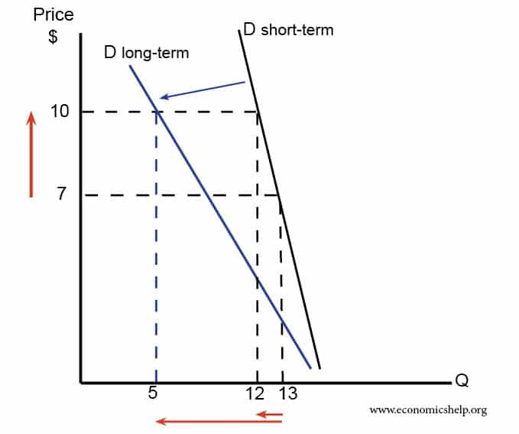

However, in the **long term**, the demand curve may shift to left as well because people respond to the higher price by looking for alternatives, for example, they buy an electric car and so no longer need petrol.

**Data To be analyzed**

|  |  |  |  |
| --- | --- | --- | --- |
| weekly sales | Holidays | Temperature | Fuel Price |
| 1650894.3 | 0 | 77.49 | 3.784 |
| 1685910.53 | 0 | 82.51 | 3.789 |
| 1627707.31 | 0 | 82.27 | 3.877 |
| 1788227.6 | 0 | 75.01 | 3.827 |
| 1704753.02 | 0 | 70.27 | 3.698 |
| 1745928.56 | 0 | 77.91 | 3.842 |
| 1771792.97 | 0 | 72.79 | 3.843 |
| 1904438.59 | 0 | 68.57 | 3.828 |
| 2076570.84 | 0 | 55.28 | 3.677 |
| 1869087.85 | 0 | 58.97 | 3.669 |
| 2950198.64 | 1 | 60.68 | 3.76 |
| 2068097.18 | 0 | 57.29 | 3.701 |
| 2429310.9 | 0 | 42.58 | 3.644 |
| 2555031.18 | 0 | 50.53 | 3.489 |
| 3487986.89 | 0 | 48.36 | 3.541 |
| 1930690.37 | 1 | 48.92 | 3.428 |
| 1683401.78 | 0 | 59.85 | 3.443 |
| 1711562.73 | 0 | 51 | 3.477 |
| 1675562.94 | 0 | 54.51 | 3.66 |
| 1632406 | 0 | 53.59 | 3.675 |
| 1867403.01 | 0 | 56.85 | 3.543 |
| 2218595.8 | 1 | 55.73 | 3.722 |
| 2168709.76 | 0 | 54.12 | 3.781 |
| 2039415.74 | 0 | 56.02 | 3.95 |
| 1990371.02 | 0 | 57.62 | 3.882 |
| 1917483.1 | 0 | 57.65 | 3.963 |
| 1930814.66 | 0 | 62.11 | 4.273 |
| 1837457.69 | 0 | 56.54 | 4.288 |
| 1815760.42 | 0 | 67.92 | 4.294 |
| 2163384.17 | 0 | 65.99 | 4.282 |
| 1974687.51 | 0 | 70.28 | 4.254 |
| 1777166.53 | 0 | 67.75 | 4.111 |
| 1712987.56 | 0 | 80.11 | 4.088 |
| 1821364.42 | 0 | 77.02 | 4.058 |
| 1792345.3 | 0 | 76.03 | 4.186 |
| 1795152.73 | 0 | 85.19 | 4.308 |

**Analysis**

**Impact of Fuel Prices on Weekly Sales of Walmart**

The provided data for the Walmart case has examined the correlation between weekly sales and fuel price fluctuations. Since the variable in question is a non-price factor, it would result in a shift of the demand curve rather than a movement along it. Nonetheless, as the specific price levels have not been specified in the data, the demand curve shift is observed in terms of both upward and downward directions, depending on whether the fuel prices have increased or decreased, respectively, along with the corresponding change in weekly sales.

**Weekly Sales VS Fuel Price**

In the Graph, the fuel price ranges from 2.574 to 3.781. Fuel price can have an impact on the demand and supply of goods, including the weekly sales of Walmart.

An increase in fuel price could lead to an increase in the cost of production and transportation, which would result in an increase in the price of goods sold. This increase in price could lead to a decrease in demand for the product, which could subsequently lead to a decrease in weekly sales.

However, the graph does not show a clear trend between fuel price and weekly sales. Therefore, to understand the impact of fuel price on weekly sales, a statistical analysis such as regression analysis could be performed to determine the relationship between the two variables. Additionally, other factors such as holiday and temperature could also be taken into account to isolate the impact of fuel price on weekly sales.

## **Relationship between weekly sales and Temperature**

The relation between temperature and weekly sales can be observed through the graph. In the graph, as temperature is a non-price determinant, it will cause the graph to shift upward and downward. From the graph, it appears that there is an inverse relationship between weekly sales and temperature. In other words, as the temperature increases, the weekly sales tend to decrease, and as the temperature decreases, the weekly sales tend to increase.

**Weekly Sales VS Temperature**

This can be observed from the data points, where we can see that when the temperature is high, the weekly sales are generally lower, and when the temperature is low, the weekly sales are generally higher. For example, the week with the highest temperature of 85.19 degrees has a relatively low weekly sales figure of 1,795,152.73, while the week with the lowest temperature of 42.58 degrees has a relatively high weekly sales figure of 2,429,310.9.